

**ECEN 5613 Lab-2 Report**

Course Name: Embedded System Design

Student Name: ***RUSHI JAMES MACWAN***

*This submission is created by Rushi James Macwan. Credits and courtesy to the TAs (Tristan and Kiran) for their immense help and support.*

Lab-1 Part-1

1. Bytes of code space my program requires in the NVRAM – 35 Bytes

Explanation:

Based on the code provided in this lab write-up and the listing file associated with the submission, the code space usage in the NVRAM looks as given below:

|  |  |  |
| --- | --- | --- |
| **NVRAM Address Range** | **Purpose for using it** | **Equivalent memory space used in terms of Bytes** |
| 0000H to 0005H | Initial Accumulator initialization and the long jump performed to the MAIN loop | 5 Bytes |
| 000BH to 001AH | This code space was utilized for the ISR routine. I acknowledge that this is not the ideal design/usage of the code space since the given code space utilization strictly overlaps with the address location for IE1 (external interrupt 1) interrupt vector address as given in the [datasheet](http://ecee.colorado.edu/~mcclurel/c501d501.pdf) (please see the below image) which begins at 0013H. | 15 Bytes |
| 0040H to 004FH | This code space was utilized for the MAIN loop. | 15 Bytes |
| **Total code space utilization:** | | **35 Bytes** |

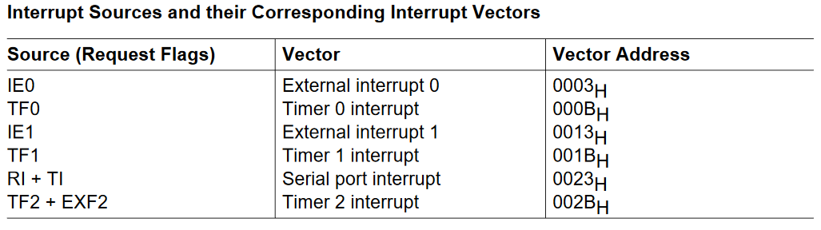

Credits: Siemens (C501 Datasheet)

1. The ISR routine execution took the following time durations (theoretically and practically):

Code vs Oscillator Cycles breakup:

1. ISR: CPL P1.7 Osc Period: 12
2. CLR TF0 Osc Period: 12
3. INC A Osc Period: 12
4. CJNE A, #07H, REPEAT Osc Period: 24
5. MOV A, #00H Osc Period: 12
6. CPL P1.5 Osc Period: 12
7. REPEAT: PL P1.7 Osc Period: 12
8. RETI Osc Period: 24

Note: Here, the red part is not practically present in the lab DSO output as the code will toggle the test pin (P1.7) only after the initial “CPL P1.7” instruction is successfully executed. Similarly, the test pin will be toggled before the RETI instruction is executed and so the practical calculation of the ISR timing based on the DSO output will exclude the first and last lines of the ISR code. For more, please refer to the entire assembly code attached with the submission. The submitted code file contains all the appropriate explanation for the code.

|  |  |
| --- | --- |
| **ISR Execution Time (Theoretical)** | **ISR Execution Time (Practical)** |
| For full ISR execution (i.e. when the Timer 0 has overflowed for 7 times in a row which equals to a period of 0.5 seconds and passes the execution through the CJNE instruction), the time consumed will be from line 1 to 8 of the ISR code which sums up to a total oscillator period of 120 cycles. For, one oscillator cycle, the time period will be 0.0904 usec and therefore for 120 cycles, the time duration will be **10.850 usec**. | For full ISR execution, based on the practical DSO output, it took **7.72 usec**. This is because the DSO will only see the code execution of lines 2-7 which theoretically amounts into 84 oscillator cycles which corresponds to 7.595 usec. The practical value differs a little from the theoretical value due to the inaccuracies of the DSO, the inaccuracies in the measurement and the measuring probes. |
| For incomplete ISR execution (cases where Timer 0 has not overflowed for 7 times and the CJNE jump is performed), the oscillator periods will be equal to that of 96 cycles (code lines 1 to 4 and 7 to 8) which corresponds to **8.680 usec**. | For incomplete ISR execution, the practical DSO output was **5.42 usec**. This is because the DSO will only see the code execution of lines 2-4 and 7 which amounts to period of 60 oscillator cycles which theoretically corresponds to 5.425 usec. Again the slight variance might be due to the above mentioned reasons. |

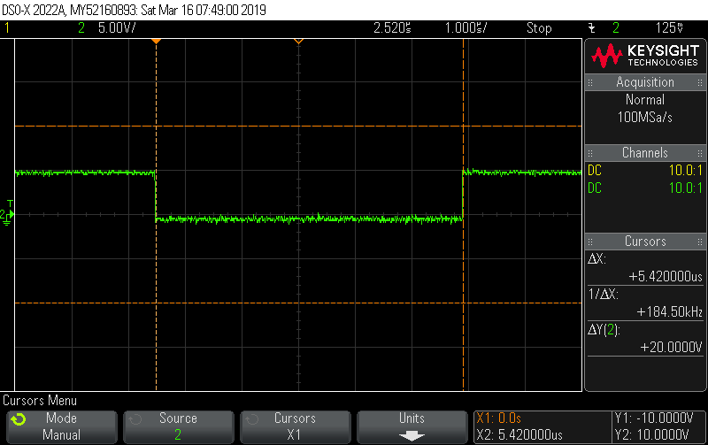

***Short ISR timing based on P1.7 toggling***

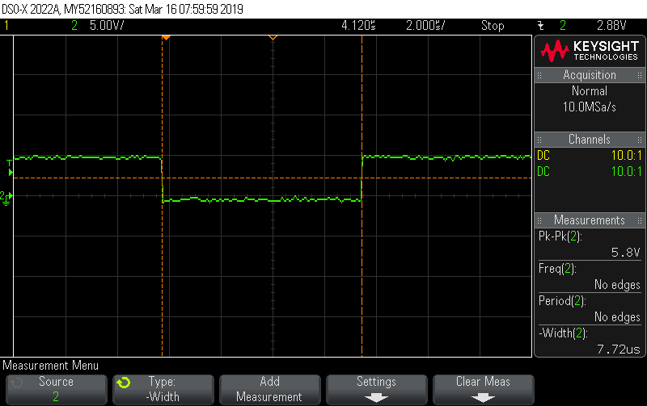

***Long ISR timing based on P1.7 toggling***

**SPLD WinSim Code Comments:**

The SPLD code takes the following parameters as inputs and outputs for the chip select logic:

|  |  |
| --- | --- |
| **Inputs** | **Outputs** |
| **A15** – the address pin on 8051. As this pin goes low, the NVRAM is activated because of the reason that the first 32kB in the memory map starting from 0000H to 7FFFH should correspond to the NVRAM address space. This directly requires that the A15 pin must be held low in order for the NVRAM to be selected. | **/OE** – The output enable pin of the NVRAM is held low (meaning that the NVRAM can send code data to the 8051) only when the chip is active and /PSEN goes low (meaning only when 8051 is actually reading the code from NVRAM). |
| **/PSEN** – the program store enable active-low pin. As this pin goes low, 8051 will be reading code from the internal/external code space (whichever is specified through hardware or software means). In our case, since we are holding the /EA line low, it means that 8051 will read code from the external code space only (in our case NVRAM) as it happens to be the external code storage device. Also, the NVRAM will be activated only when all of the three signals: A15, /PSEN and /EA go low. | **/CE** – The chip enable signal goes low (which means that NVRAM becomes active for usage) only when all the input signals go low. The reason for this is already mentioned on the left: to consume as less power as possible. |
| **/EA** – Although the /EA line is externally grounded so that it always remains low and has no decision making in the SPLD output, it is kept in order for future labs. While /EA line is not low, the external storage NVRAM will not be turned on to save power while it will be turned on only and only when all of the three input signals are low to ensure that the board consumes as less power as possible. |  |

Please, refer to the SPLD code provided in the submission for more information.

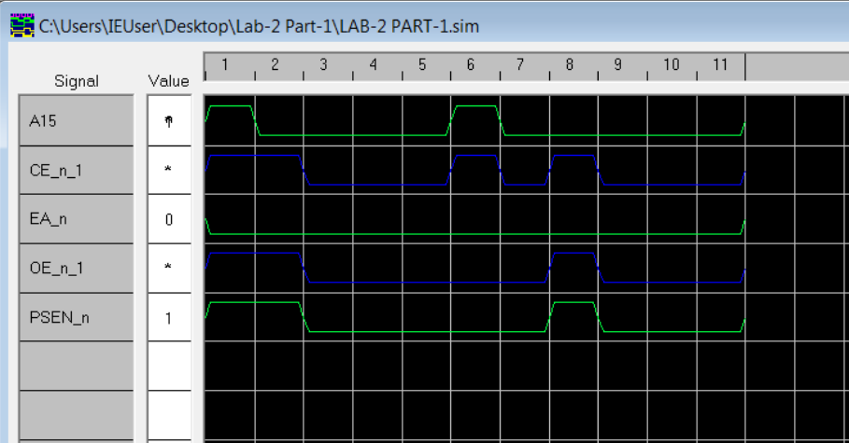

***SPLD WinSim Output***

**Schematic Diagram:**

The schematic diagram has been included in the submission, both in image format and the KiCad project file format.

**Wiring Description:**

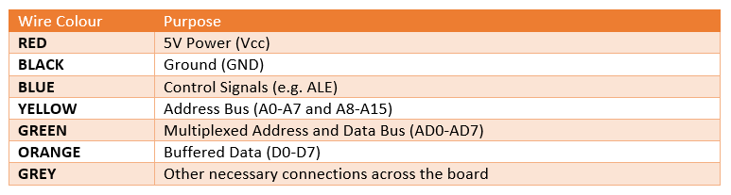

Lab-1 Part-2

**MSP432 Codes:**

The MSP432 Codes have been successfully modified based on the example codes. The screenshots folder contains the LED on-off timing of 200 ms as per the requirement (which is included here). The submitted code files include all the appropriate explanation for the code.

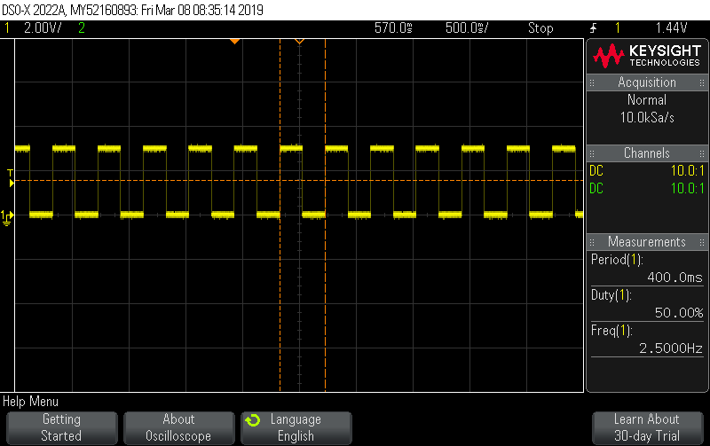

***MSP432 LED blinking timing (200 ms on/off timing)***